LOCAL PENSIONS PARTNERSHIP INVESTMENTS LIMITED
Lancashire County Pension Fund
Pension Fund Committee | 21 June 2019
Responsible Investment Report

Title of Paper | Quarterly Report on Responsible Investment (2019 Q1)
Lead Officer: | Frances Deakin  Head of Responsible Investment  Local Pensions Partnership Investments Ltd  frances.deakin@localpensionspartnership.org.uk
Appendices | None

- Executive Summary

This report provides members of the Pension Fund Committee of Lancashire County Pension Fund (LCPF) with a quarterly update on Responsible Investment (RI) matters.

- Introduction

The Fund's approach to RI is articulated within an Investment Strategy Statement (ISS) which confirms that the objective of RI is to decrease investor risk, improve risk-adjusted returns and assist the Fund's adherence to the UK Stewardship Code. LCPF’s ISS is supplemented by a Responsible Investment Policy which explains that the Fund's preferred approach to RI encompasses four main areas of activity:
- Voting Globally
- Engagement through Partnerships
- Shareholder Litigation
- Active Investing

Responsibility for the practical implementation of the Fund's approach to RI is devolved to Local Pensions Partnership Investments Ltd (LPPI) as LCPF's provider of investment management services. The report which follows provides the Committee with an update on RI activity during the period 1 January to 31 March 2019 plus insights on current and emerging issues.

- Voting Globally

Through its investment in the LPPI Global Equities Fund (GEF) LCPF owns units in a pooled fund which invests in listed companies globally. Investors in the GEF delegate the control and exercise of shareholder voting to LPPI. This reflects that clients owning units in the GEF are beneficial owners in common but do not directly own shares in underlying companies.

LPPI exercise shareholder voting rights for the GEF centrally rather than delegating voting to individual asset managers and take account of voting recommendations from an external provider of proxy voting and governance research (ISS) in accordance a Sustainability Voting Policy designed to ensure the consideration of ESG factors within analysis. LPPI review voting recommendations and take the final decision on all voting.

In the first quarter of 2019 shareholder voting headlines for the GEF were as follows:

LPPI Global Equities Fund (GEF)

Total company meetings taking place | 69
Total resolutions  (management and shareholder proposals) | 883
Total company proposals in the period | 857
Total shareholder proposals in the period | 26

Company Proposals
Voting Supported Management | 791 | 92%
Voting Opposed Management | 66 | 8%

Shareholder Proposals
Shareholder proposals supported by LPPI | 12 | 46%
Votes against shareholder proposals | 14 | 54%

The following table summarises resolutions by type and indicates where opposition voting was concentrated in Q1.

 | Proposals
 | For | Against | Withhold | Total
Anti-takeover Related | 2 |  |  | 2
Capitalization | 34 | 1 | 3 | 38
Director Related | 423 | 28 | 2 | 453
Non-Salary Compensation | 71 | 8 | 4 | 83
Preferred/Bondholder | 2 | 2 |  | 4
Reorg. and Mergers | 41 |  | 2 | 43
Routine/Business | 218 | 8 | 8 | 234
SH-Compensation | 1 | 4 |  | 5
SH-Corp Gov | 1 |  |  | 1
SH-Director Related | 4 | 5 |  | 9
SH-Health/Env | 1 | 1 |  | 2
SH-Other/Miscellaneous | 1 | 2 |  | 3
SH-Routine/Business | 4 | 1 | 1 | 6
Total | 803 | 60 | 20 | 883

LPPI voted against or withheld support for management proposals in 66 instances (across 15 company meetings).

This included opposing management nominations in the election / re-election of 30 directors. Voting reflected concerns with the composition and independence of company boards as a whole, and with the independence of individual Board members.

LPPI voted against all non-independent directors at the Canon AGM (Japanese Technology company) as four of the six board members are insiders (33% independence) and the board lacks gender diversity. (Result: 8% against)

LPPI voted against the re-election of a director proposed by JM Financials (Indian Investment Bank) as the individual failed to attend at least 75% of board meetings in the fiscal year with no satisfactory explanation. (Result: 9% against)

LPPI voted against all directors at Groupo LALA (Mexican consumer staples) for poor practices including failing to disclose the names of director nominees in sufficient time, not adequately disclosing director remuneration and bundling the election of its directors into a single voting item. (Result: all proposals passed – detailed voting statistics unavailable).

Management proposals on compensation arrangements prompted 12 opposition votes. These were in reaction to examples of poor practices and weak corporate governance including inadequate information being released in an untimely manner, a lack of appropriate remuneration capping and inadequate disclosure of performance conditions.

At Hua Hong Semiconductor Ltd (Hong Kong Information Technology) LPPI voted against the Share Option Scheme due to performance conditions not being adequately disclosed and directors being eligible to receive options who were involved in the administration of the compensation programme. (Result: 16% against)

At Pepkor Holdings Ltd (South African consumer discretionary) LPPI voted against the Remuneration Implementation Report in opposition to a large increase in the CFO’s basic remuneration without adequate supporting information/explanation (Result:6% against).

LPPI supported 12 shareholder proposals across 11 company meetings in Q1.
6 featured at the AGM of Hyundai Mobis Co. (South Korean automotive parts manufacturer) and included proposals to increase the number of directors, nominate candidates as outside (independent) directors, and nominate candidates for the Audit Committee). None of the resolutions passed.

At CGI Group Inc. (Canadian IT Consulting & Services) an advisory vote on executive compensation was proposed (seeking the opportunity for shareholders to give their opinions on CGI’s executive compensation policy). The proposal reflected that it is increasingly common practice for company AGMs in Canada to accommodate a shareholder “say on pay” but, in this case, the resolution gained only 23% support.

At Starbucks Inc (USA Restaurants) a proposal sought a comprehensive report on reducing the company’s environmental impacts by stepping up the scale and pace of sustainable packaging initiatives. The company responded by outlining initiatives already underway which include its "Next Gen Cup Challenge," a $10 million commitment to develop a compostable, recyclable cup and two other environmental initiatives, its "Strawless Lids" commitment to eliminate plastic straws globally by 2020 and its "Greener Stores" goal to build 10,000 Greener Stores globally by 2025. The Board argued that given consistent reporting on its environmental performance and goals, and reported intentions to "scale up its enterprise sustainability efforts," the additional analysis and reporting would be duplicative and unnecessary. Whilst it did not pass, the resolution received 44.5% of votes, significantly closer to achieving a majority than a comparable resolution in 2018 which gained 29% support.

At the Toronto-Dominion Bank AGM (Canadian Diversified Bank) shareholders considered a detailed proposal (incorporating 6 requirements) to restrict the Bank’s financing of existing and future energy projects and other high emitting activities. The broad intentions behind the proposal (that banks should routinely evaluate the risks faced from climate change and its regulation, should seek to limit financing for unsustainable projects, and should routinely report on the risks faced) are laudable, but the highly directive and prescriptive nature of the proposal counselled against giving support given the Bank’s existing strong track record of environmental stewardship, alignment with appropriate best practice and commitment to public disclosure. Toronto-Dominion Bank is the only Canadian bank listed on the Dow Jones Sustainability World Index, is a signatory to the Equator Principles (a risk management framework for determining, assessing and managing environmental and social risk in projects) is annually disclosing on its climate change management to CDP and is reporting publicly against the Taskforce on Climate Related Financial Disclosure (TCFD) framework.

Members can view details of shareholder voting for all meetings via the LPP website where quarterly reports for the GEF are made publicly available.
https://www.localpensionspartnership.org.uk/what-we-do/investment-management

- Engagement through Partnerships

LPPI regularly participates in collaborations which aim to make progress on commonly held issues by co-ordinating the efforts of multiple investors. Key partners include the Local Authority Pension Fund Forum (LAPFF) the Pensions and Lifetime Savings Association (PLSA) the Principles of Responsible Investment (PRI) the Institutional Investor Group on Climate Change (IIGCC) the LGPS Cross Pool RI Group, and the UK Pension Scheme RI Roundtable.

LAPFF

LAPFF has long been LCPF's preferred engagement partner. The Fund is a long-standing member of the Forum and the Head of Fund and Chair of the Pension Fund Committee both currently sit on the LAPFF Executive.

LAPFF’s engagement programme reflects annual assessment of key priorities arising from across the collective equity holdings of LAPFF members. The Workplan for 2019 was considered and agreed by members at the last LAPFF Business Meeting (17 April 2019) following feedback received from funds as part of an annual consultation process.

On a quarterly basis LAPFF provide a summary of the engagement activities undertaken on behalf of member funds which is available from the LAPFF website. http://www.lapfforum.org/publications/qrtly-engagement-reports/

Quantified across thematic topics, engagement activity by LAPFF in 2019 Q1 was as follows:
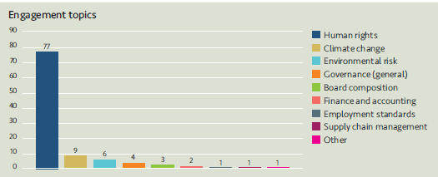

The predominant theme in Q1 was human rights, the relatively large number of interactions reflecting LAPFF’s participation in two broader investor initiatives, one on the safety of mine tailings dams following the loss of life caused by the failure of the Vale tailings dam in Brumadinho Brazil in late January 2019 (on which further information appears below) and a second encouraging best practice by insurance companies in the provision of micro insurance policies offering fair and transparent products to the least well served sections of the community.

The 82 companies engaged with and the topics covered by LAPFF in Q1 were as follows:
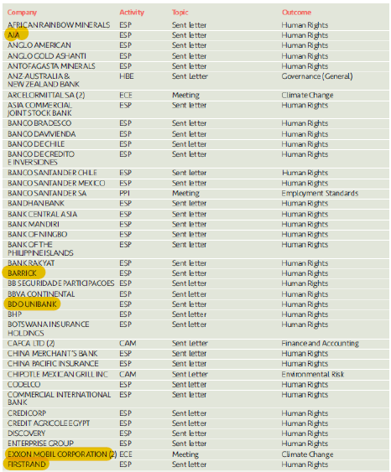

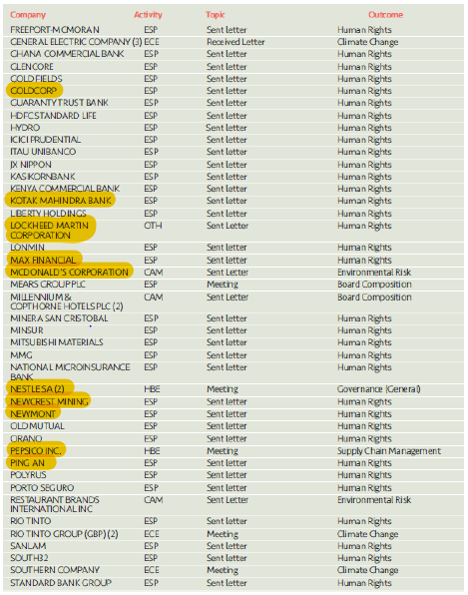
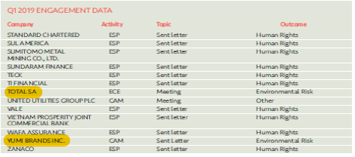
17 of the companies engaged with (highlighted above) are held within the LPPI Global Equities Fund in which LCPF owns units.

LPPI is engaging via a range of investor collaborations on an ongoing basis and is communicating with investee companies and other parties including policy makers, regulators, service providers and external asset managers. Examples of engagement from Q1 include the following activities and initiatives.

Investor Mining & Tailings Safety Initiative
LPP was a signatory to an investor letter to 683 mining companies globally seeking improved public disclosure on the extent of their involvement with tailings dams (Tailings Storage Facilities). This investor initiative follows the disaster at the Vale mine in Brumadinho Brazil in January 2019 which killed +300 people. The letter to mining companies was signed by 96 investors representing $10.3tn and recognises that inadequate information exists on the incidence and scale of tailings storage globally (which prevents an assessment of both the risks faced and how well they are being managed by companies).

The campaign to establish publicly available baseline information on the incidence of Tailings Storage Facilities has escalated and is now being convened as The Investor Mining & Tailings Safety Initiative through a steering committee chaired by the Church of England Pensions Board and the Swedish Council on Ethics (for the AP Funds which make up the Swedish pension system). The initiative is backed by the PRI, who, along with the International Council on Mining and Metals and United Nations Environment Programme (UNEP) have appointed Professor Bruno Oberle as an Independent Chair to oversee a review aimed at establishing an international standard for tailings dams to improve the safety of mine waste storage facilities across the world.

The review will establish an international standard for the safe management of tailings storage facilities that can be applied to all tailings dams wherever they are located and whoever operates them. Regular updates on the progress of the investor initiative are being provided and reportedly the programme is on the radar of banks and insurers interested in the availability of improved data for risk quantification as a result of the increased disclosure being sought.

Further information on the initiative is available here: https://www.churchofengland.org/investor-mining-tailings-safety-initiative

Climate Action 100+ (Update)
At its last meeting the Committee learned that LPPI had co-filed its first shareholder proposal at a company AGM, calling on Exxon Mobil to set short, medium, and long-term targets for emissions reductions in line with the Paris Agreement.
LPP was one of 30+ investors who co-ordinated to co-file the proposal.

It was outlined that Exxon was utilising a process overseen by the Securities and Exchange Commission (SEC) seeking not to table the proposal at the AGM. Ultimately this move was successful – the proposal did not make it onto the ballot paper for the AGM on 29 May 2019 after the argument was accepted that it could be interpreted as seeking to micro-manage the company. The SEC judgement was despite receiving additional representation from shareholders (including LPP) who were supportive of the resolution.

A war of words between Exxon and the proposers has ensued, with the two funds who led the co-filing (the Church Commissioners for England, and New York State Common Retirement Fund) utilising a process called exempt solicitation to publicly share thoughts on the engagement process (and their AGM voting intentions) with other shareholders via documents formally published on the SEC website. The proponents made a case for voting against all members of the Exxon Board as a signal of significant concerns, and for supporting other shareholder proposals featured on the ballot (which included separating the role of CEO and Chairman and establishing a new Board Committee on Climate Change to evaluate Exxon Mobil’s strategic vision and response to climate change).

Exxon responded by placing a statement on their website calling into question the accuracy of comments made about the engagement underway with CA100+. Full details are available here.

The Exxon AGM falls into Q2 and at the time of writing only preliminary meeting results were available on the outcome of voting. These indicate that none of the proposals achieved the majority vote needed, the largest support (40%) being for an independent Chairman. The confirmed results from the Exxon AGM will be shared with the Committee as part of Q2 reporting.

5 Shareholder Litigation

LPPI employ Institutional Protection Services (IPS) as an external provider of litigation monitoring services to ensure shareholder litigation cases affecting securities owned by the GEF are known about, claims are filed in a timely way and progress is monitored and followed up with Claims Administrators. In addition, IPS monitor cases relating to shares held by LCPF in the period before the Fund pooled its listed equity investments from November 2016. Litigation can arise quite some time after shares have been sold and monitoring new cases and referring back to historic records to establish rights of ownership is an ongoing task.

IPS provide LPPI with monitoring information on a quarterly basis detailing the number of cases investigated. The monitoring report for Q1 2019 confirms that 4 new potential cases have been identified where the Fund may have an entitlement to join a class action and eligibility is being assessed, there are a further 2 cases where eligibility has been confirmed and a claim will be filed and 7 which have been discounted following further analysis. In Q1 the Fund received a disbursement of monies relating to one filed claim that has reached settlement.

6. Active Investing

The LCPF Responsible Investment Policy describes active investing as the search for sustainable investments which meet LCPF’s requirements for strong returns combined with best practice in ESG and corporate governance. The Fund has not set allocations for investments within specific sectors or identified impact themes but in general favours investments with positive social outcomes and has expressed an interest in understanding where current investments are delivering social benefits in addition to generating investment returns. Examples of socially positive investments are available from across the asset classes the fund invests in.

Case Study: Private Equity – Investing in Healthcare (SDG 3)
LCPF’s strategic asset allocation to Private Equity is 5% of the portfolio.
13% of the Fund’s current private equity investments are in the health care sector.

Through managers Advent Life Sciences and Endeavour Vision, LCPF is investing in private equity funds which partner and provide development capital to specialist companies turning break-through science into approved medicines and medical products.

The Endeavour Medtech Growth Fund has invested in 12 med tech companies to date, with a total investment value of over EUR 115 million. Companies include Symetis, creator of next generation heart valve replacement solutions that offer an alternative to high-risk open-heart surgery; Gynesonics, a ground-breaking treatment for uterine fibroids without the need for a hysterectomy (preserving the ability to conceive); Vertiflex, developers of a minimally invasive device to reduce pain and improve mobility for patients suffering a painful narrowing of the spinal canal (lumbar spinal stenosis) and Relievant, a new system focused on a specific form of chronic low back pain which eliminates the need for patients to use opioids and have spinal injections.

Advent Life Sciences have invested over £300m into early stage drug and device development over the last ten years, contributing to 14 regulatory approvals (innovative science translated into approved medicines or products). Examples include UniQure’s Glybera drug (the first gene therapy approved by the European Medicines Agency) and CardiAQ Valve Technologies’ minimally invasive valve replacement which provides an alternative to open heart surgery. Currently Advent is seeking to contribute to the relief of social pressures through innovations which address drug resistant bacteria, pain management solutions to reduce opioid usage and developments in cancer immunotherapies.

LCPF made a EUR 25m commitment (GBP 18m) to the Endeavour Medtech Growth Fund in 2014 and invests in two funds managed by Advent Life Sciences. The first (Fund II) comprises a commitment of GBP 20m made in 2015 and the second (Fund III) a commitment of GBP 15m made in December 2018.

The focus of UN Sustainable Development Goal 3 is to ensure healthy lives and promote well-being for all at all ages. SDG 3 includes a target (3.1) to reduce premature mortality from non-communicable diseases by one third by 2030, and an accompanying indicator (3.1.4) related to the mortality rate attributable to cardiovascular disease, cancer, diabetes and chronic respiratory disease. LCPF’s private equity investments in healthcare innovation are contributing both generally, and in some cases directly, to progress against SDG 3.

Other Insights
- FRC Consultation: Proposed Revision to the UK Stewardship Code (Update)

As reported to the Committee at its last meeting, a consultation on a revised UK Stewardship Code ran between 30 January 2019 and 29 March 2019. LPP made a response to the consultation which is publicly available from the FRC website
here.

The proposals to revise the current code outline a more stretching and rigorous reporting regime which has intentionally gone beyond requirements specified within the revised Shareholder Rights Directive. This reflects that effective stewardship is being identified as an important part of institutional investors' responsibilities to their clients.

The draft 2019 Code is an integral part of the UK's overall corporate governance framework. It significantly raises the standard expected from institutional investors and aims to create a market for stewardship driven by a demand from asset owners and beneficiaries for better quality information about how asset managers and service providers fulfil their responsibilities. Those who become signatories will be making a serious commitment to maintaining and improving the quality and integrity of UK financial markets. The FRC will be devoting more resource to evaluating the quality of disclosure of both policies and activities.

One of the chief changes proposed is an extension to current reporting requirements (which can be seen to directly address criticisms of the boilerplate and box ticking approach seen to have developed under the current code).

Under the revised Stewardship Code proposals, signatories will be required to
- produce and submit a Policy and Practice Statement (PPS) to the FRC. This must disclose their stewardship approach and explain how it complies with Principles and Provisions defined by the Code. It must also contain disclosure on corporate purpose, values and culture and how these enable obligations to clients and beneficiaries to be met;
- produce and submit an Annual Activities and Outcomes Report (AAOR) to the FRC. This must demonstrate and confirm
  - compliance with the approach explained in the PPS
  - activities undertaken to implement code provisions in the preceding 12 months
  - evaluation of how well stewardship objectives have been met, and/or activities have enabled clients to meet their objectives
  - the outcomes achieved.
AAORs and PPS will need to be made publicly available.

The changes are a significant step up and will involve a greater reporting burden for LGPS pension funds which are required to be signatories to the UK Stewardship Code and reporting on their compliance with its requirements.

A final version of the revised code is still awaited, though the timetable for adoption is very short. It is intended that a 2019 Stewardship Code will be published on 16th July 2019 and new requirements will come into effect from that point, with first statements of compliance due to be submitted for assessment by the end of the year. The consultation papers include only limited information on the FRC assessment process for evaluating the quality of stewardship arrangements and it is not clear what scoring or ranking mechanism will be adopted and what levels of performance will be differentiated.

Once a final version of the revised Code (and accompanying guidance) have been published, LCPF will need to revisit the Fund’s current statement of compliance and address new requirements for considerably more detailed disclosure.

- LPP: First detailed reporting against the Principles of Responsible Investment

LPP became a PRI signatory in July 2018 and reported in detail against the PRI framework for the first time in March 2019 (covering the period to 31 December 2018). The outcome of the annual reporting process is a publicly available Transparency Report for each signatory which will be accessible from the PRI website in due course. Separately, LPP will receive a confidential Assessment Report providing a relative score based on the PRI’s evaluation of the arrangements and activities described.

Reporting to the PRI significantly extends the level of information being publicly released on LPP’s approach to stewardship and RI and gives greater context to our policies and examples of our actions in practice which contribute to supporting greater transparency.

